Assignment 2
Name : Om A. Akiwate
PRN : 255209003
Batch : BT-4

B.1 Missing Value Audit
Load air_quality.csv.
- Print the shape and first 6 rows of the dataset.
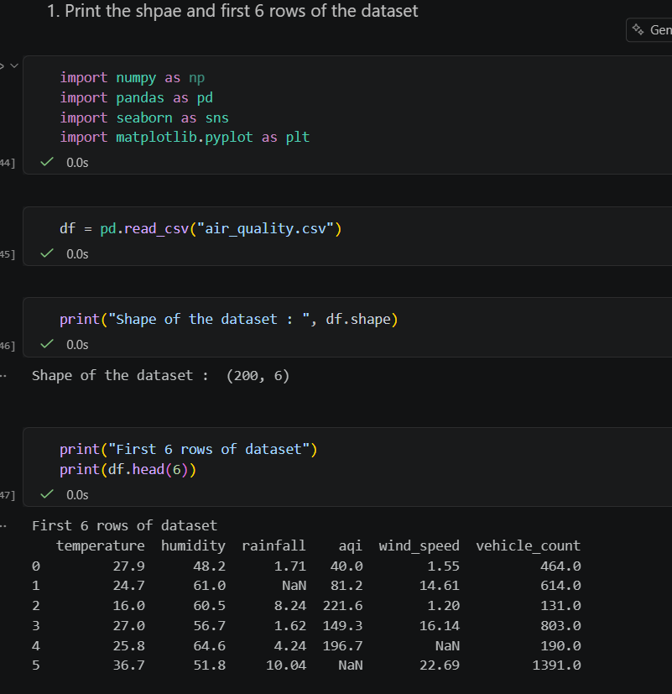

- Print missing count and missing percentage per column. Identify the column with the highest missing rate and state whether any column exceeds 15%.
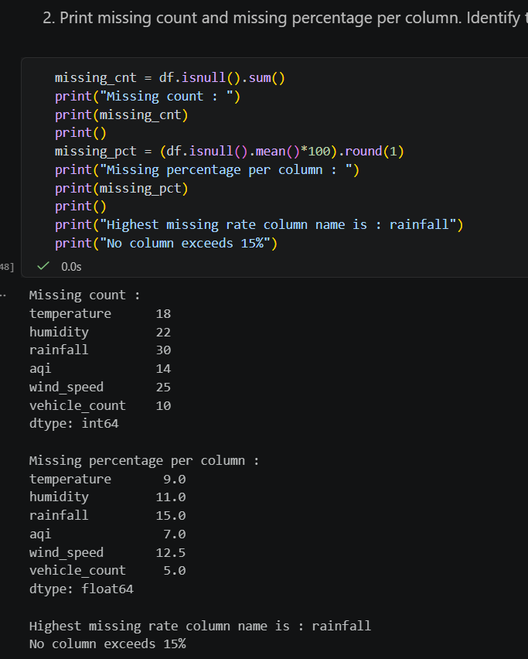

- Draw a missing-value heatmap with a descriptive title. In a markdown cell write one sentence on what the pattern suggests about sensor behaviour.
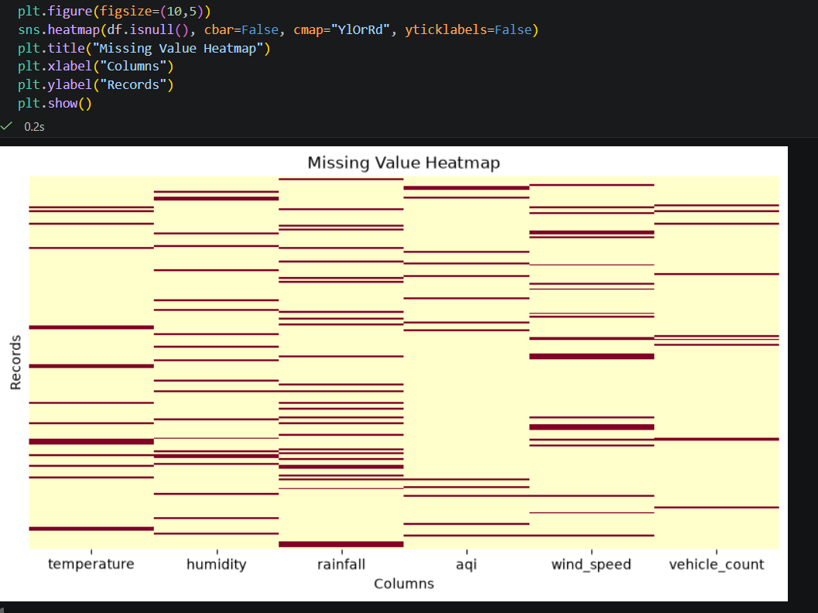
- Run describe() and note for each column whether mean is above or below the median. Capture this in a markdown cell — you will use it to justify imputation choices below.
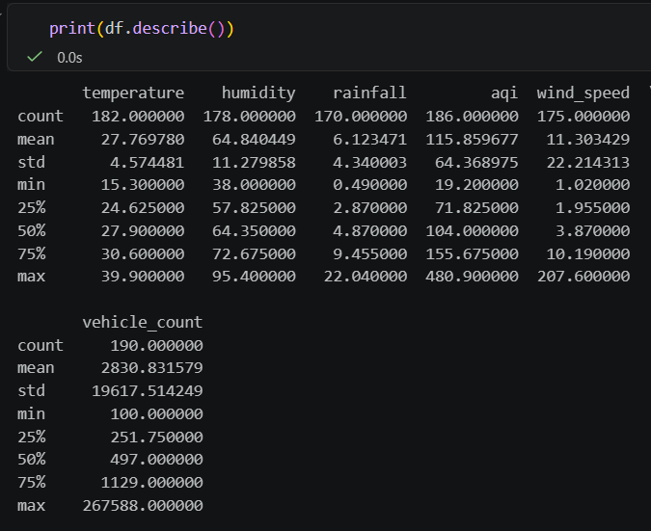

B.2 Imputation
- In a markdown cell, state which statistic (mean or median) you chose for each column and why, referencing the distribution family and your describe() findings.
- Apply imputation to all six columns and confirm zero missing values remain.
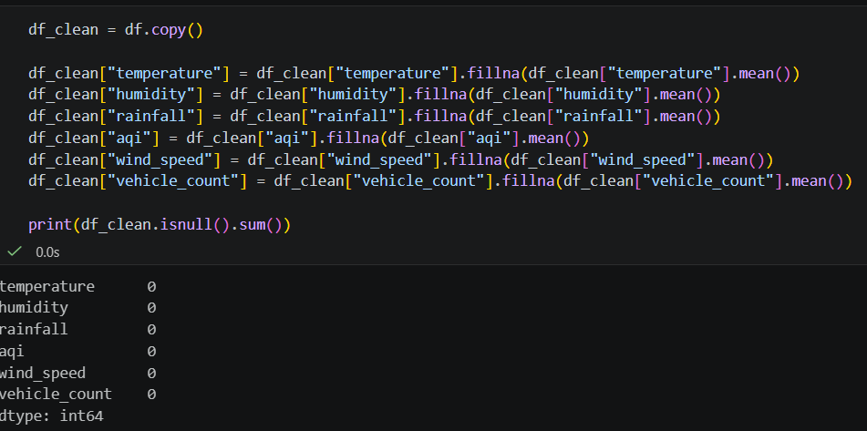
- For rainfall, plot before-and-after KDE curves on the same axes. Write one sentence: did imputation shift the centre, and is that expected given your choice of statistic?
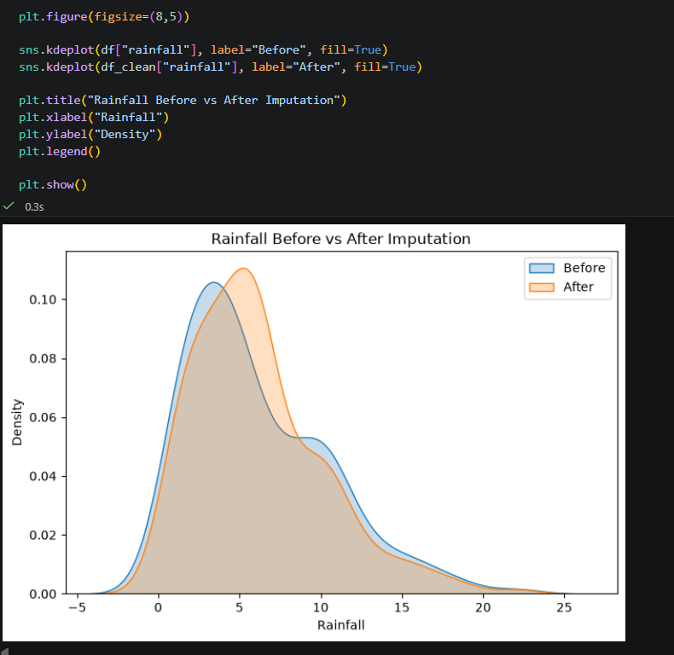

B.3 Histograms
- Draw histograms of all six columns in a 2×3 grid. Write one sentence per column describing its shape and matching it to the expected distribution family.

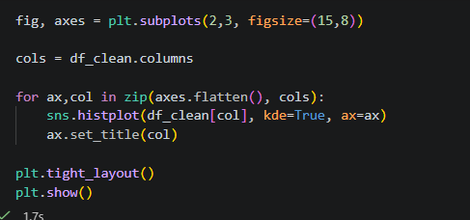

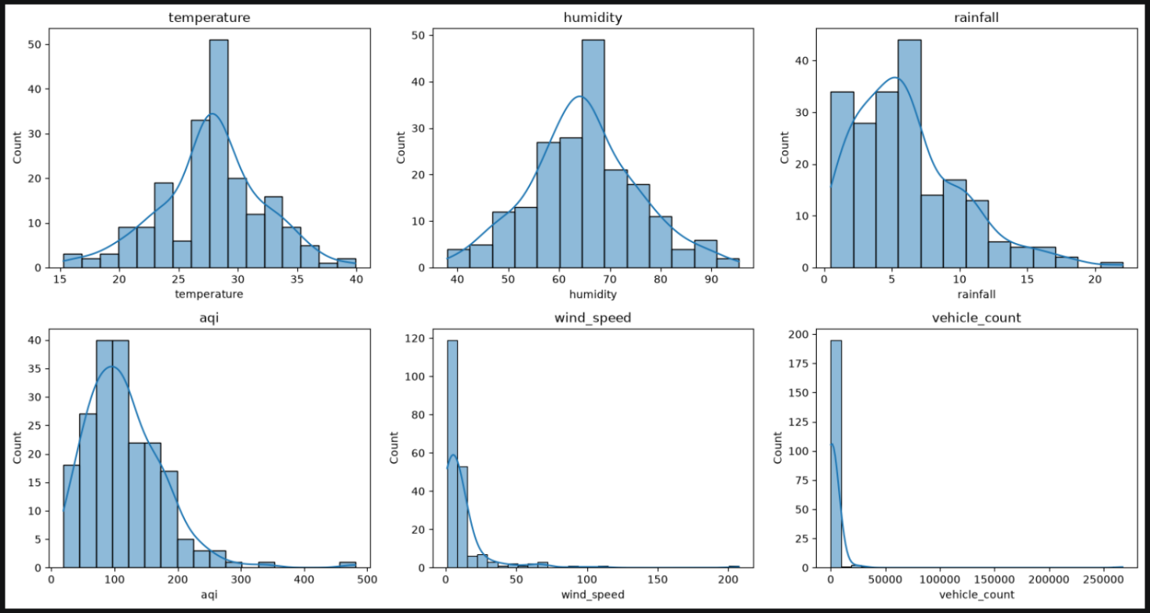
- Draw a single histogram for aqi with a KDE overlay and vertical lines for mean and median. From this plot, state whether aqi is right-skewed or left-skewed and justify using the positions of the two lines.
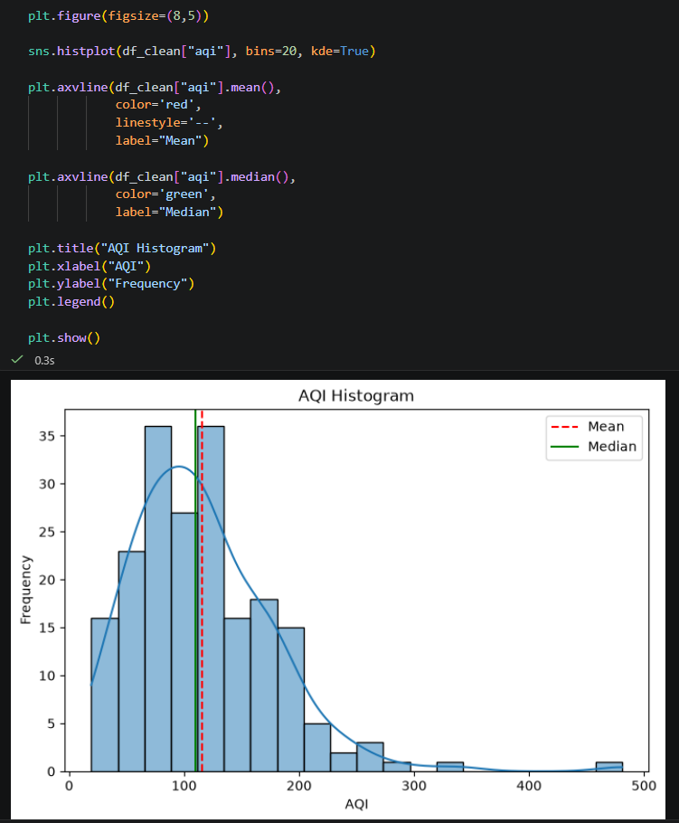

- Draw vehicle_count twice side by side — normal y-axis and log-scale y-axis. Explain what the log-scale appearance reveals about this column's distribution.
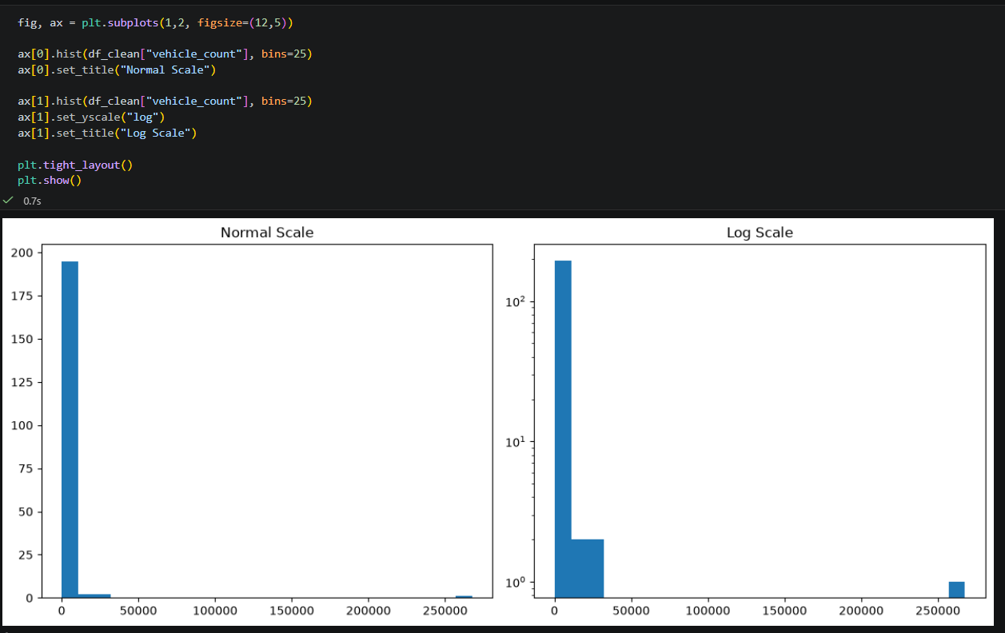

B.4 Box Plots and Outlier Detection
- Draw z-scored box plots of temperature, humidity, and rainfall on one figure. State which column has the most outlier points and whether that matches its distribution family.
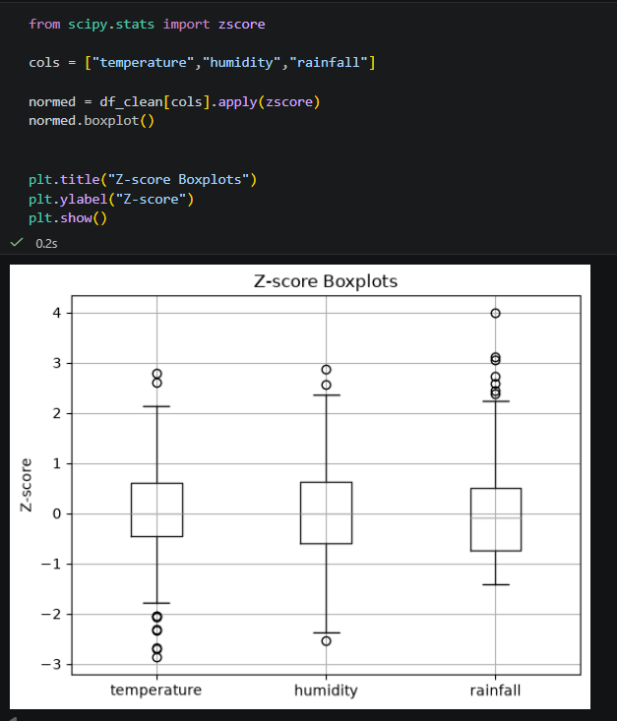

- Apply the IQR rule to wind_speed: print the number of outliers and show those rows. Write one sentence interpreting what an extreme wind_speed city-day might represent.
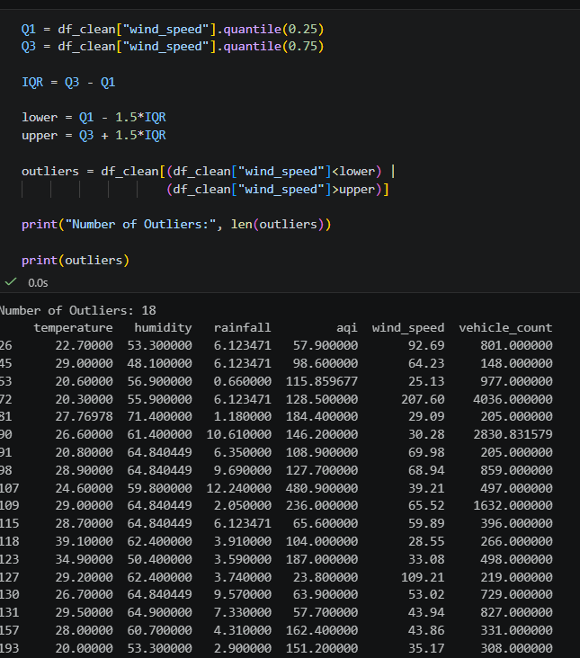

- Draw violin plots of temperature, humidity, rainfall, and aqi side by side. Contrast the shape of the Normal violins with the Gamma violins in a markdown cell.
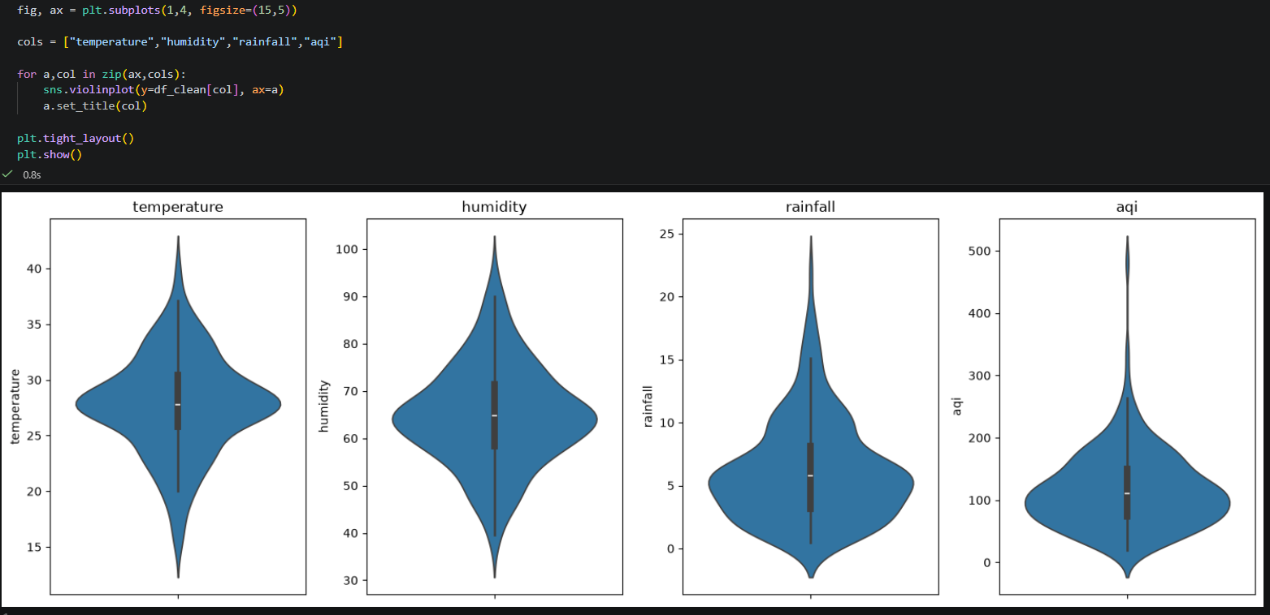

B.5 Scatter, Pair Plot, and Correlation
- Draw three scatter plots: (a) humidity vs aqi, (b) wind_speed vs aqi, (c) temperature vs rainfall. Write one sentence per plot on whether and in which direction a trend is visible.
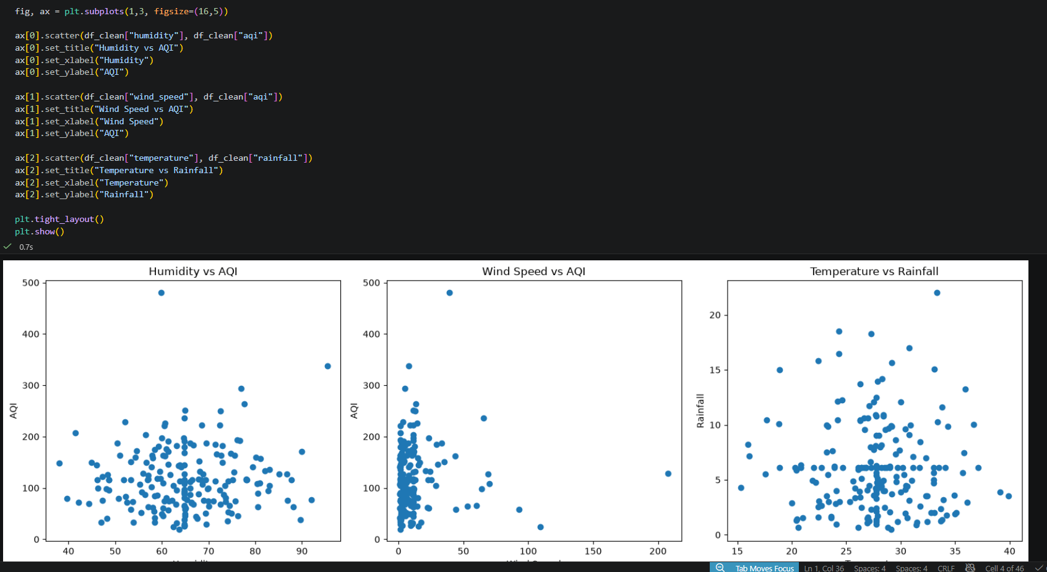

- Redraw wind_speed vs aqi coloured by temperature (coolwarm, with colour bar). Describe whether high-temperature days cluster at high or low AQI and give a physical reason.
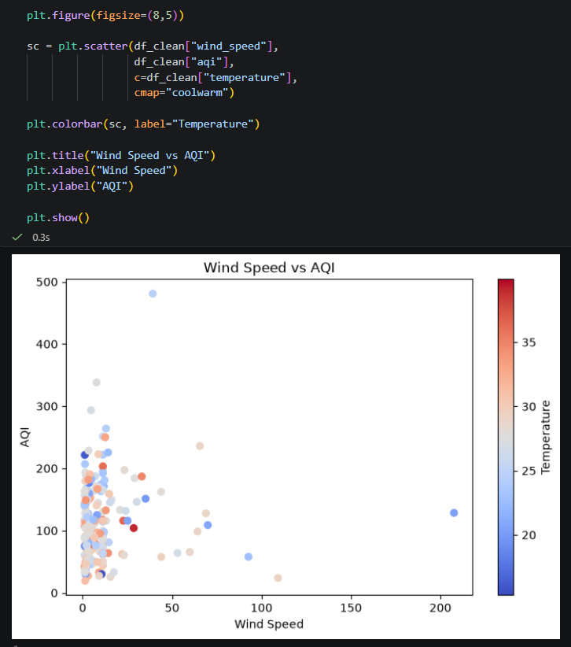

- Draw the correlation heatmap. State the pair with the highest absolute correlation and explain whether it matches what you saw in the scatter plots.
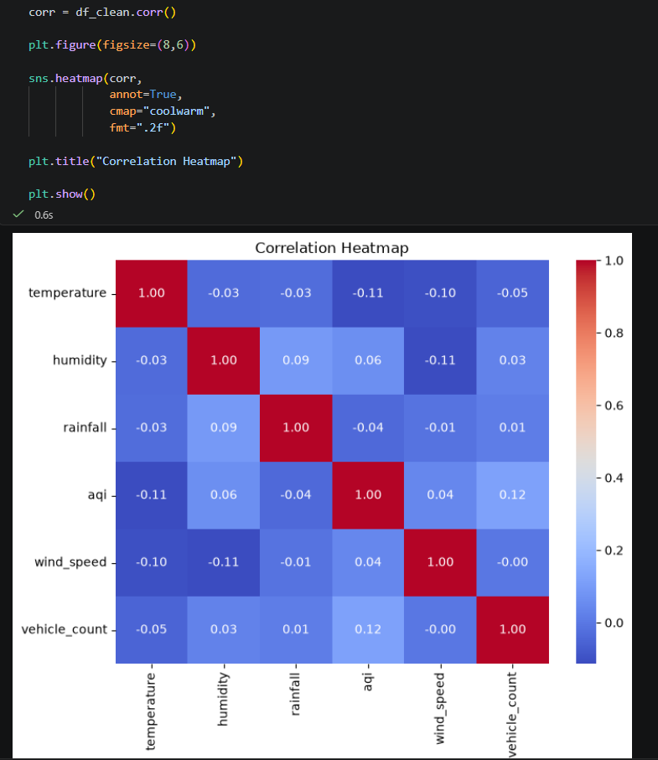

B.6 Take-Home (Submit with Notebook)
- Create df_dropped (drop all rows with any missing value) and df_imputed (df_clean). Compare shapes and draw side-by-side rainfall histograms. How much data is lost by dropping? Does the shape change?
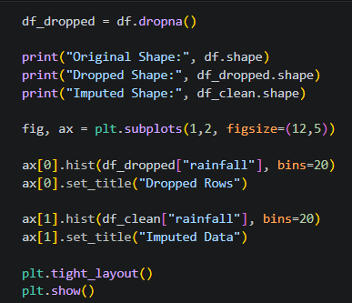
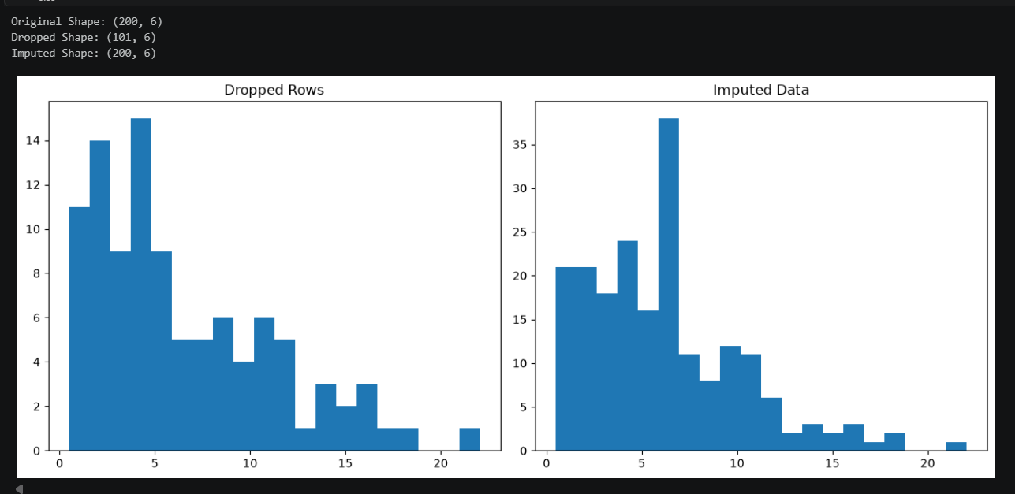

- Design one additional visualisation of your own choice not already used in B.1–B.5. Write two sentences: what does it show, and why did you choose this chart type?


